E – COMMERCE WEBSITE
A Project report Submitted in partial Fulfilment of the requirement for the Award of Degree
Bachelor of Technology
IN
Computer Science & Engineering


DEPARTMENT OF COMPUTER SCIENCE & ENGINEERING
MEERUT INSTITUTE OF TECHNOLOGY, MEERUT



Affiliated To
DR. A.P.J. ABDUL KALAM TECHNICAL UNIVERSITY
UTTAR PRADESH, LUCKNOW

CERTIFICATE

I hereby declare that the work which is being presented in the project report entitled, “E - COMMERCE”, in partial fulfilment of the requirements for the award of degree of Bachelor of Technology submitted in Computer Science and Engineering of Meerut Institute of Technology, Meerut, is an authentic record of my own work carried out under the supervision of and refers other researcher’s works which are duly listed in the reference section.

The matter presented in this Project has not been submitted for the award of any other degree of this or any other university
NITESH KUMAR
ARJUN
Mohd Harish
Aayush Kumar
This is to certify that the above statement made by the candidates is correct and true to the best of my knowledge.

COUNTERSIGNED BY
MR. Aayush Singhal

ACKNOWLEDGEMENT
It gives us a great sense of pleasure to present the report of the B. Tech Project undertaken during B. Tech. Third Year. We owe special debt of gratitude to
Mr. Aayush Singhal, Department of Computer Science & Engineering, Meerut Institute of Technology, Meerut for his constant support and guidance
Throughout the course of our work. His sincerity, thoroughness
and perseverance have been a constant source of inspiration for us. It is only his cognizant efforts that our endeavours have seen light of the day. We also take the opportunity to acknowledge the contribution of DR. GAURAV SHARMA, Head, Department of Computer Science & Engineering, Meerut Institute of Technology, Meerut for his full support and assistance during the development of the project.
We also do not like to miss the opportunity to acknowledge the contribution of all project co-coordinators and faculty members of the department for their kind assistance and cooperation during the development of our project. Last but not the least, we acknowledge our friends for their contribution in the completion of the project.
Name: NITESH KUMAR Name: ARJUN
Roll No:2002920100050 Roll No.: 2002920100019
Date: Date:
Signature: Signature:

Name: Mohd Harish Name: Aayush Kumar
Roll No: 2002920100045 Roll No: 2002920100026
Date: Date:
Signature: Signature:

ABSTRACT
Our project name is E – COMMERCE WEBSITE.
Recently the e-commerce platform is playing an important role in some areas its activities are a subset of e-business activities. The aim of this paper is to build and develop a reliable website based on the e-commerce theories, developing effective well designed web pages. For implement the selling online website, it needs to use current technologies to achieve this goal. As a first stage, it should setting up online ecommerce store with easy-to-use. Then improve the customer experience, and implementing electronic payment methods. All these techniques should be based on plan according to strategy of electronic commerce with implement the current technology to ensure a good revenue to the website.

INTRODUCTION

E-Commerce formerly referred to as Electronic Commerce is the trading of several of goods & services over a wide area of electronic means such as the Internet or any other Computer Networks. The various sources where the e-commerce is successfully being running and the uses of e-Commerce are mobile commerce, electronic funds transfer, supply chain management, internet marketing, online transaction processing, management systems and automated data collection systems. E-Commerce allows the exchange of data over electronic means in order to facilitate the financing & payment aspects of business transaction. Within the help of e-Commerce, an organization is benefitted through effective communications & better business conducts.

PURPOSE AND APPLICABILITY
There are several ways to categorize e-commerce applications.
- Business-to-Business: - Business-to-business (B2B) is a scenario or activity in which two firms conduct a commercial transaction with one another. In short, commerce with other firms. B2B transactions are different from other kinds of e-commerce as they sell items to other businesses rather than to consumers. Alibaba, Woodpecker, eWorldTrade, and other B2B companies are examples. This type of software is created by a high-end web development firm.
- Business-to-Consumer: - Business-to-consumer (B2C) is described as a transaction directly between a business and an end consumer. A customer can view and choose the product shown on the website and buy product/services as by the approval of business. They are known as online retailers that sell products and services online. One of the best online marketplace websites like Amazon is an example of a B2C business model.

- Consumer-to-Business: - Another type of interaction between consumers and businesses is consumer-to-business. The transaction takes place on a website where customers buy products or services, and businesses bid on and buy. Examples of C2B platforms include stock and employment boards.

- Consumer-to-Consumer: - Consumer-to-consumer (C2C) transactions are those that take place between consumers. Consumer-to-consumer transactions made it easy for people to purchase, sell, and exchange. eBay (online consumer auction site), newspapers (online ads), and Craigslist are all examples of C2C transactions. The primary objective of C2C is to facilitate the connection between buyers and sellers. They call it a peer-to-peer business model. Websites of this sort are created through categorized app development.

PROGRAM CODE
<!DOCTYPE html>
<html lang="en">
<head>
<meta charset="UTF-8">
<meta http-equiv="X-UA-Compatible" content="IE=edge">
<meta name="viewport" content="width=device-width, initial-scale=1.0">
<title>Mere Website</title>
<link rel="stylesheet" href="Css.css">
<link rel="stylesheet" href="https://cdnjs.cloudflare.com/ajax/libs/font-awesome/4.7.0/css/font-awesome.min.css">
</head>
<body>
<div class="header">
<div class="container">
<div class="navbar">
<div class="logo">
<h1>#A҉R҉J҉U҉N҉</h1>
</div>
<nav>
<ul id="MenuItems">
<li><a href="">Home</a></li>
<li><a href="">Products</a></li>
<li><a href="">About Us</a></li>
<li><a href="">Contact</a></li>
<li><a href="">Account</a></li>
</ul>
</nav>
</div>
<div class="row">
<div class="col-1">
<h1>Give Your Workout <br> A New Style! </h1>
<p>Success isn't always about greatness. It's about
consistency. Consistent <br> hard work gains success. greatness
will come. </p>
<a href="" class="btn">Explore Now &#8594;</a>
</div>
<div class="col-1">
<img src="D:\Arjun Saini\images\image1.png">
</div>
</div>
</div>

</div>
</div>

<! ------ featured categories -->

<div class="categories">
<div class="small-container">
<div class="row">
<div class="col-2">
<img src="D:\Arjun Saini\images\pexels-photo-388517.webp">
</div>
<div class="col-2">
<img src="D:\Arjun Saini\images\pexels-darya-sannikova-4691100.jpg">
</div>
<div class="col-2">
<img src="D:\Arjun Saini\images\pexels-photo-3756771.webp">
</div>
</div>
</div>
</div>

<!------ Boys T-shirt -->

<div class="small-container">
<h2 class="title">Boys T-shirt</h2>
<div class="row">
<div class="col-3">
<img src="D:\Arjun Saini\images\boys t-shirt\ec7e03f6952fa6e9019d4a428a136b91.jpg" height="320px" >
<h4>Red Printed T-Shirt</h4>
<div class="rating">
<i class="fa fa-star"></i>
<i class="fa fa-star"></i>
<i class="fa fa-star"></i>
<i class="fa fa-star"></i>
<i class="fa fa-star-o"></i>
</div>
<p>Rs.350 <s>Rs.1099</s></Rs></p>
<h4>Size XL,M</h4>
<h4><s>Free delivery</s></h4>
</div>

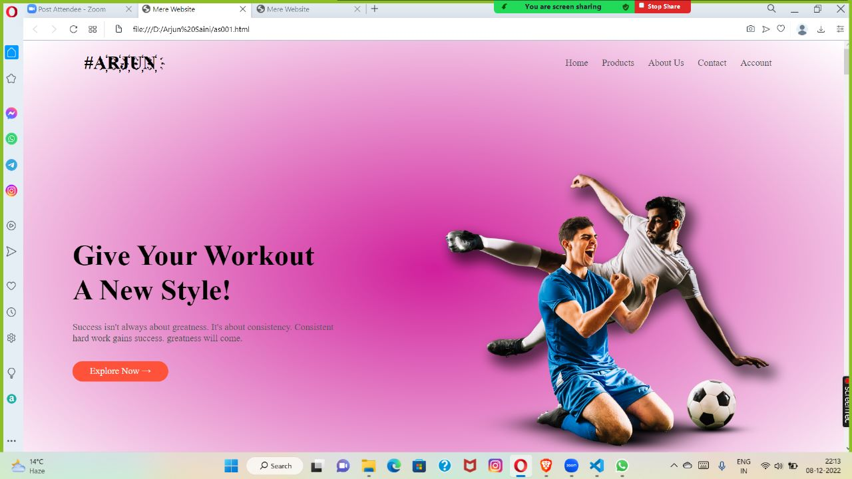
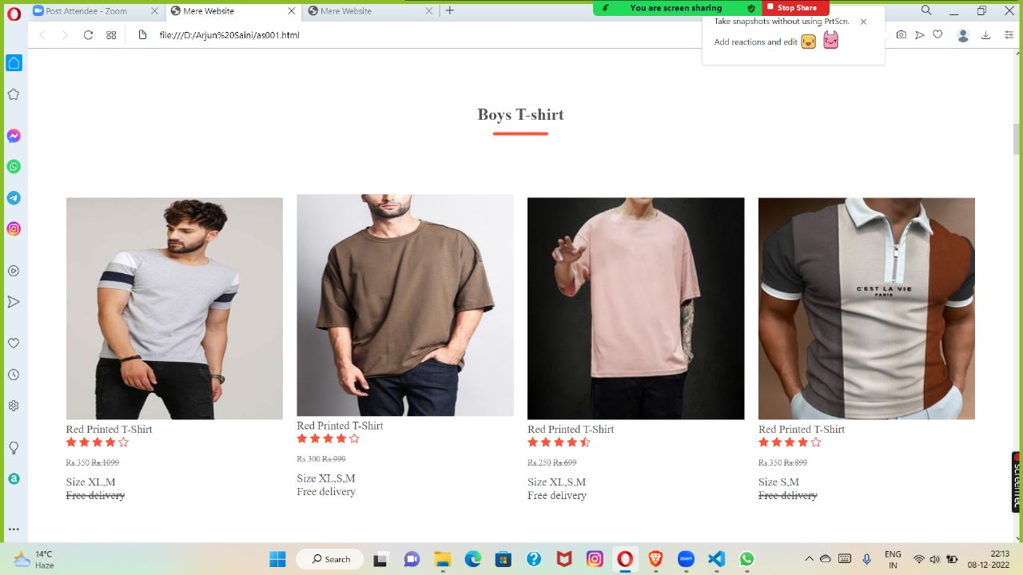

LANGUAGE USED
- HTML
- CSS

HTML
HTML stands for Hypertext Markup Language. It is used to design web pages using a markup language. HTML is the combination of Hypertext and Markup language. Hypertext defines the link between web pages. A markup language is used to define the text document within the tag which defines the structure of web pages.

<!DOCTYPE html>: This is the document type declaration (not technically a tag). It declares a document as being an HTML document. The doctype declaration is not case-sensitive.

<html>: This is called the HTML root element. All other elements are contained within it.

<head>: The head tag contains the “behind the scenes” elements for a webpage. Elements within the head aren’t visible on the front-end of a webpage. HTML elements used inside the <head> element include:

<style>-This html tag allows us to insert styling into our webpages and make them appealing to look at with the help of CSS.

<title>-The title is what is displayed on the top of your browser when you visit a website and contains title of the webpage that you are viewing.

<base>-It specifies the base URL for all relative URLs in a document.

<noscript>– Defines a section of HTML that is inserted when the scripting has been turned off in the users browser.

<script>-This tag is used to add functionality in the website with the help of JavaScript.

<meta>-This tag encloses the meta data of the website that must be loaded every time the website is visited. For eg:- the metadata charset allows you to use the standard UTF-8 encoding in your website. This in turn allows the users to view your webpage in the language of their choice. It is a self-closing tag.

<link>– The ‘link’ tag is used to tie together HTML, CSS and JavaScript. It is self-closing.

<body>: The body tag is used to enclose all the visible content of a webpage. In other words, the body content is what the browser will
show on the front-end.

CSS
Cascading Style Sheets, fondly referred to as CSS, is a simply designed language intended to simplify the process of making web pages presentable. CSS allows you to apply styles to web pages. More importantly, CSS enables you to do this independent of the HTML that makes up each web page. It describes how a webpage should look: it prescribes colors, fonts, spacing, and much more. In short, you can make your website look however you want. CSS lets developers and designers define how it behaves, including how elements are positioned in the browser.

CSS saves time: You can write CSS once and reuse the same sheet in multiple HTML pages.

Easy Maintenance: To make a global change simply change the style, and all elements in all the webpages will be updated automatically.

Search Engines: CSS is considered a clean coding technique, which means search engines won’t have to struggle to “read” its content.

Superior styles to HTML: CSS has a much wider array of attributes than HTML, so you can give a far better look to your HTML page in comparison to HTML attributes.

Offline Browsing: CSS can store web applications locally with the help of an offline cache. Using this we can view offline websites.

